

The Somaiya School

Academic Year 2020-2021

A Project Report

On

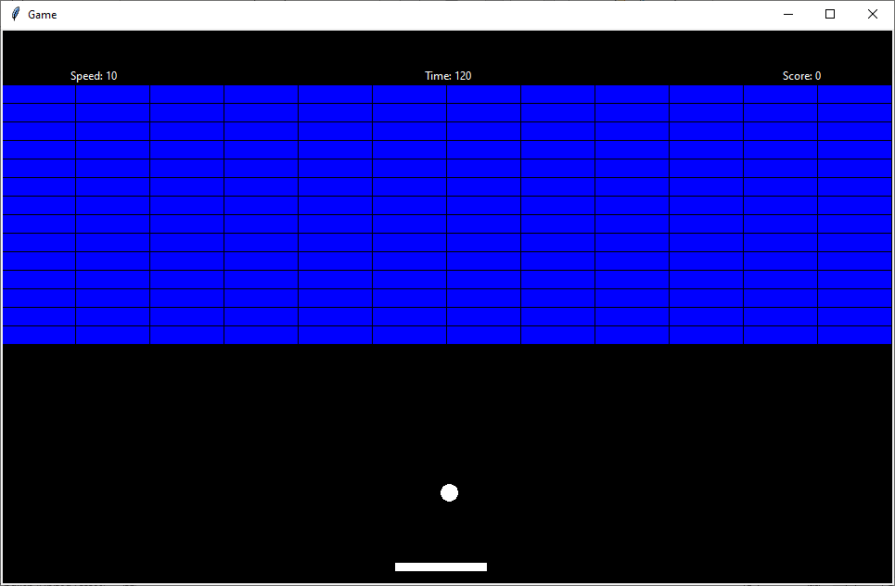Brick Breaker

**Submitted By:**

ABHIJEET MANKANI

Grade: XI Science

Roll No.: 10

Gr. No.: 064



The Somaiya School

Certificate

This is to certify that **ABHIJEET MANKANI**, student of standard **XI Science** has successfully completed the **Computer Science Project Work** in partial fulfillment of curriculum of the **CENTRAL BOARD OF SECONDARY EDUCATION** for the year **2020-2021**.

Ms. Anuja Ajay Ms. Parveen Shaikh

Teacher Incharge Principal

Date: School Seal

Acknowledgement

During the process of preparation of the project, I have got immense help from various persons, without which it would not have been possible to achieve this goal.

First of all, I would like to place on record the effort that our respected Principal has made in providing us fully equipped laboratory.

Our Computer Teacher has rendered all support and guidance from time to time to see that I am thorough to the project.

We are equally thankful to our parents for giving us moral support and ideas to carve out this project.

Table Of Contents

1. INTRODUCTION 5

2. PACKAGE/MODULE USED IN THE PROJECT 6

3. CODING 8

4. LIMITATIONS 22

5. REQUIREMENTS 23

6. CONCLUSION 24

7. BIBLIOGRAPHY 25

# Introduction

This is the Recreation of the Retro game Brick Breaker in Python.

The User Controls the paddle with his/her mouse to try and break as many bricks as possible with the ball in the given time (2 minutes).

The ball bounces off the walls, the ceiling, the paddle, and bricks.

By bouncing on each brick, the brick is destroyed, and the player gains 2 points.

If the player fails to hit the ball with his paddle, the ball falls below, and the user loses 5 points.

If the user clears ~95%(162 of 168 bricks) of the bricks, the bricks are reset, and the user gains a bonus of 50 points.

The maximum number of bricks on the screen is 168.

To add an extra dimension, the player can control the speed of the ball, to take a risk of sorts;

* By increasing the speed, he can hit more bricks in the given time, but make it more likely to lose points. (maximum speed cap is 20)
* By decreasing the speed, he can make it less likely to lose points, but he can hit lesser bricks in the given time. (minimum speed cap is 5)

Help:

Paddle is controlled by using the mouse/pointing device.

Speed is increased using ‘F’ key

Speed is decreased using ‘S’ key

# Package/Module Used In The Project

1. math module: Gives access to various mathematical function in python

functions:

* floor – It rounds down the number to the Greatest Integer Smaller than or equal to the passed Argument

1. time module: Gives access to various time-related functions in python

functions:

* perf_counter – Returns Time (in seconds) since the program started
* sleep – Stops the program execution for a specific number of seconds

1. Tkinter module: One of the Python Standard Libraries, used for adding GUI support to programs:

* Tk – Creates a root for the GUI
* Canvas – creates a canvas, to show stuff on

1. keyboard module: Allows Access to keyboard related functions

* wait – Stops Program Execution until the specified key is presses
* is_pressed – Checks if the specified key is pressed

1. pyautogui module: A module which can help automate your computer, and navigate through the GUI:

* moveTo – moves the mouse cursor to the specifies coordinates

1. classes module: A user defined module that contains all the classes’ structure in it

**User Defined Functions:**

start_game(): Starts the game

motion(): To get mouse's X Position – to be used only for binding with root.bind()

awake_ball(): Makes the ball move again, after being reset, or after the game starts – to be used only for binding with root.bind()

brickTileToIndex(): Converts Row-Column Location to Index

brickPresent(): Checks if brick's present value is 1(it is present) or not(it is removed)

resetBricks(): Resets the Brick wall

reset(): Rests the Ball, and Paddle Position, is called when ball falls down

removeAndBounceOffBrick(): Removes the brick that the ball collides with, and bounce off it

speed_increment(): You can decrease the speed of the ball, making it more likely to lose points, but possibly have a higher max score. – to be used only for binding with root.bind()

speed_decrement(): You can decrease the speed of the ball, making it less likely to lose points, but have a lower possible max score. – to be used only for binding with root.bind()

def move(): Defines the basic physical movement of ball, according to speed, bounces it off the walls and resets the ball when it goes below paddle

def call(): Place holder function, which is run every frame, to calculate current position of things

# Coding

**main.py :**

from math import floor

from time import perf_counter, sleep

from tkinter import Canvas, Tk

import keyboard

from pyautogui import moveTo

from classes import *

FPS = 30

c_width, c_height = 963, 600

brickGap = 2

brickCol = 12

brickRow = 18

brickCounter = brickCol * 14

brickWidth, brickHeight = 80, 20

brickGrid = [None] * (brickCol * brickRow)

# Initializing The Tkinter canvas

root = Tk()

root.title("Game")

canvas = Canvas(root, width=c_width, height=c_height)

canvas['bg'] = '#000000'

canvas.pack()

font = ('Algerian', 30, 'bold italic')

start_text_box = canvas.create_text(c_width / 2,

                                    c_height / 2,

                                    fill="#FFFFFF",

                                    text="Press Enter to Start The Game",

                                    font=font)

game_started = False

continue_ = True

def start_game():

    canvas.delete(start_text_box)

    game_started = True

score = 0

score_text = "Score: " + str(score)

score_box = canvas.create_text(c_width - 100,

                               50,

                               fill="#FFFFFF",

                               text=score_text)

started = False

total_time = 120

time_left = total_time

time_text = "Time: " + str(time_left)

time_box = canvas.create_text(c_width / 2, 50, fill="#FFFFFF", text=time_text)

# get screen width and height

ws = root.winfo_screenwidth()  # width of the screen

hs = root.winfo_screenheight()  # height of the screen

# calculate x and y coordinates for the Tk root window

x = (ws / 2) - (c_width / 2)

y = (hs / 2) - (c_height / 2)

# set the dimensions of the screen

# and where it is placed

root.geometry('%dx%d+%d+%d' % (c_width, c_height, x, y))

prev_mouse_x = mouse_x = c_width / 2

ball = Ball(c_width / 2 + 1, c_height - 100, 0, 10, canvas)

sleep_for_ball = True

paddle = Paddle(431.5, canvas)

speed_text = "Speed: " + str(ball.speedY)

speed_box = canvas.create_text(100, 50, fill="#FFFFFF", text=speed_text)

canvas.update()

def motion(event):

    '''To get mouse's X Position'''

    global mouse_x

    mouse_x = event.x

root.bind('<Motion>', motion)

def awake_ball(event):

    '''Makes the ball move again, after being reset, or after the game starts'''

    global sleep_for_ball, start_time, started, time_left, time_box, info

    sleep_for_ball = False

    if (not (started) and game_started):

        started = True

        start_time = perf_counter()

        time_left = total_time

        time_text = "Time: " + str(time_left)

        canvas.itemconfigure(time_box, text=time_text)

    try:

        canvas.delete(info)

    except:

        pass

root.bind('<Button-1>', awake_ball)

def brickTileToIndex(TileCol, TileRow):

    '''Converts Row-Column Location to Index'''

    return (TileCol + brickCol * TileRow)

def brickPresent(TileCol, TileRow):

    '''Checks if brick's present value is 1(it is present) or not(it is removed)'''

    brickIndex = brickTileToIndex(TileCol, TileRow)

    return (brickGrid[brickIndex].present == 1)

def resetBricks():

    '''Resets The Brick wall '''

    global brickGrid, brickCounter

    for col in range(brickCol):

        for row in range(brickRow):

            index = brickTileToIndex(col, row)

            brickGrid[index] = Brick(col, row, 1, brickWidth * col,

                                     brickHeight * row, canvas)

    for i in range(brickCol * 3):

        brickGrid[i].delete(canvas)  # remove the brick

    for i in range(brickCol * (brickRow - 1), brickCol * brickRow):

        brickGrid[i].delete(canvas)  # remove the brick

    brickCounter = brickCol * brickRow

def reset():

    '''Rests The Ball, and Paddle Position, is called when ball falls down'''

    global sleep_for_ball, score

    sleep_for_ball = True

    paddle.movement(canvas, (c_width / 2) - (paddle.width / 2) - paddle.x, 0)

    ball.movement(canvas, paddle.x + paddle.width / 2 + 1 - ball.x,

                  c_height - 100 - ball.y)

    ball.speedX = 0

    moveTo(ws / 2, hs / 2)

    if (game_started):

        '''-5 score on ball falling down'''

        score -= 5

    score_text = "Score: " + str(score)

    canvas.itemconfigure(score_box, text=score_text)

resetBricks()

def removeAndBounceOffBrick():

    '''Removes the brick that the ball collides with, and bounce off it'''

    global ball, brickCounter, score, score_text, score_box

    Col = floor(ball.x / brickWidth)

    Row = floor(ball.y / brickHeight)

    if (Col < 0 or Col >= brickCol or Row < 0 or Row >= brickRow):

        return  # bail out of function to avoid illegal array positioning usage error to occur

    else:

        brickIndex = brickTileToIndex(Col, Row)

        # so, we know the area we've overlaped has a brick present and not already broken

        if (brickGrid[brickIndex].present == 1):

            prevBallX = ball.x - ball.speedX

            prevBallY = ball.y - ball.speedY

            prevCol = floor(prevBallX / brickWidth)

            prevRow = floor(prevBallY / brickHeight)

            BothTestsFailed = True

            if (prevCol != Col):  # Ball came in horizontally

                adjacentBrickIndex = brickTileToIndex(prevCol, Row)

                # make sure reflecting side is not blocked off

                if (brickGrid[adjacentBrickIndex].present != 1):

                    BothTestsFailed = False

                    ball.speedX *= -1

            if (prevRow != Row):  # Ball came in vertically

                adjacentBrickIndex = brickTileToIndex(Col, prevRow)

                # make sure reflecting side is not blocked off

                if (brickGrid[adjacentBrickIndex].present != 1):

                    BothTestsFailed = False

                    ball.speedY *= -1

            if (BothTestsFailed):

                ball.speedX *= -1

                ball.speedY *= -1

            brickCounter -= 1

            score += 2

            # +2 Score for every brick broken

            score_text = "Score: " + str(score)

            canvas.itemconfigure(score_box, text=score_text)

            brickGrid[brickIndex].delete(canvas)  # remove the brick

            if (brickCounter <= 5):

                for i in brickGrid:

                    i.delete(canvas)

                resetBricks()

                score += 50

                # +50 Score on removing all bricks except 6

                score_text = "Score: " + str(score)

                canvas.itemconfigure(score_box, text=score_text)

def speed_increment(event):

    '''You can decrease the speed of the ball, making

        it more likely to lose points, but possibly have a higher max score.'''

    if (sleep_for_ball):

        ball.speedY += 1

        ball.speedY = min(ball.speedY, ball.max_speed)

        speed_text = "Speed: " + str(ball.speedY)

        canvas.itemconfigure(speed_box, text=speed_text)

        canvas.update()

def speed_decrement(event):

    '''You can decrease the speed of the ball, making

        it less likely to lose points but have a lower possible max score.'''

    if (sleep_for_ball):

        ball.speedY -= 1

        ball.speedY = max(ball.speedY, ball.min_speed)

        speed_text = "Speed: " + str(ball.speedY)

        canvas.itemconfigure(speed_box, text=speed_text)

        canvas.update()

root.bind('<F>', speed_increment)

root.bind('<S>', speed_decrement)

root.bind('<f>', speed_increment)

root.bind('<s>', speed_decrement)

def move():

    '''Defines the basic physical movement of ball, according to speed,

    bounces it off the walls and resets the ball when it goes below paddle'''

    global ball, brickCounter, paddle, mouse_x, prev_mouse_x, sleep_for_ball, speed_text, info, continue_

    if (not (sleep_for_ball)):

        ball.movement(canvas, ball.speedX, ball.speedY)

        if (ball.x <= 10 or ball.x >= c_width - 10):

            ball.speedX *= -1

        if (ball.y <= 0):

            ball.speedY *= -1

        if (ball.y >= c_height - 20):

            if (ball.x >= paddle.x - paddle.width / 2 - 10

                    and ball.x <= paddle.x + paddle.width / 2 + 10):

                ball.speedY *= -1

                X = ball.x - (paddle.x)

                ball.speedX = X * 0.35

            else:

                reset()

        removeAndBounceOffBrick()

        continue_ = False

    elif (not continue_):

        info = canvas.create_text(

            c_width / 2,

            3 * c_height / 4,

            text="Left Click to Continue\nor Press F/S to change speed",

            font=font,

            justify="center",

            fill='#FFFFFF')

        root.update()

        continue_ = True

    paddle.movement(canvas, mouse_x - paddle.x, 0)

    prev_mouse_x = mouse_x

root.geometry(str(c_width) + 'x' + str(c_height))

def call():

    '''Place holder function, which is run every frame, to calculate current postion of things'''

    global time_left, time_box, started, game_started, start_time, canvas

    if (game_started):

        move()

        curr_time = perf_counter()

        if (started and time_left > 0):

            time_left = round(total_time - (curr_time - start_time))

            time_text = "Time: " + str(time_left)

            canvas.itemconfigure(time_box, text=time_text)

        if (time_left <= 0):

            ball.speedY = 0

            ball.speedX = 0

            sleep_for_ball = True

            for i in brickGrid:

                i.delete(canvas)

                font = ('Algerian', 40, 'bold italic')

            canvas.create_text(c_width / 2, c_height / 2, text="Your Final Score is " + str(score), font=font, justify="center", fill="#FFFFFF")

            font = ('Algerian', 20, 'bold italic')

            canvas.create_text(c_width / 2, 4 * c_height / 5, text="Press 'E' to exit", font=font, justify="center", fill="#FFFFFF")

    if (not (game_started)):

        # Runs one time, at the start of game, to give the user instructions

        keyboard.wait('enter')

        canvas.delete(start_text_box)

        font = ('Algerian', 15, 'bold italic')

        info = canvas.create_text(c_width / 2, 3 * c_height / 4, text="Left Click to Start Moving", font=font, justify="center", fill='#FFFFFF')

        root.update()

        sleep(2)

        canvas.itemconfigure(info, text="Move your cursor to control paddle")

        root.update()

        sleep(2)

        canvas.itemconfigure(info, text="You have 2 minutes to score as many\npoints as possible")

        root.update()

        sleep(3)

        canvas.itemconfigure(info, text='''Press F or S to\nincrease/decrese you ball speed\n(You can only change the speed while the ball is still)''')

        root.update()

        sleep(5)

        canvas.itemconfigure(info, text="Press E at any time to exit the program.")

        root.update()

        sleep(3)

        canvas.delete(info)

        root.update()

        reset()

        started = False

        game_started = True

        time_left = total_time

while 1:

    # The Clock which runs everything FPS frames per second

    call()

    root.update_idletasks()

    root.update()

    sleep(1 / FPS)

    if keyboard.is_pressed('E'):

        exit()

**classes.py :**

# Predefined Canvas Width and Height values

c_height = 600

c_width = 963

class Brick:

    def __init__(self, _col, _row, _present, leftX, topY, canvas):

        self.col = _col

        self.row = _row

        self.width = 80

        self.height = 20

        self.present = _present

        self.id=canvas.create_rectangle(leftX, topY, leftX + self.width, topY + self.height, fill='#0000FF')

    def delete(self, canvas):

        '''Deletes the brick'''

        if(self.present):

            canvas.delete(self.id)

            self.present=0

class Paddle:

    def __init__(self, _x, canvas):

        self.x = _x

        self.y = c_height - 20

        self.width = 100

        self.height = 10

        self.id=canvas.create_rectangle(self.x-self.width/2, self.y - self.height/2, self.x + self.width/2, self.y + self.height/2, fill='#FFFFFF')

    def movement(self, canvas, mov_x, mov_y):

        '''To move the paddle'''

        canvas.move(self.id, mov_x, mov_y)

        self.x+=mov_x

        self.y+=mov_y

class Ball:

    def __init__(self, _x, _y, _speedX, _speedY, canvas):

        self.x = _x

        self.y = _y

        self.r = 10

        self.speedX = _speedX

        self.speedY = _speedY

        self.max_speed = 20

        self.min_speed = 5

        self.id = canvas.create_oval(self.x - self.r, self.y - self.r, self.x + self.r, self.y + self.r, fill='#FFFFFF')

    def movement(self, canvas, mov_x, mov_y):

        '''To move the ball'''

        canvas.move(self.id, mov_x, mov_y)

        self.x+=mov_x

        self.y+=mov_y

**Output:**

1. 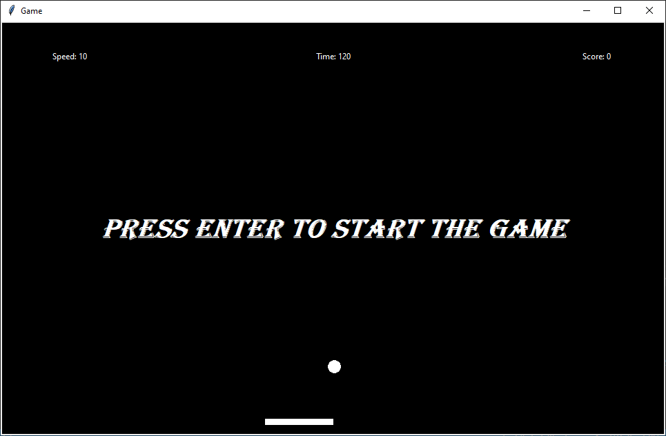**Screenshot 1**
2. 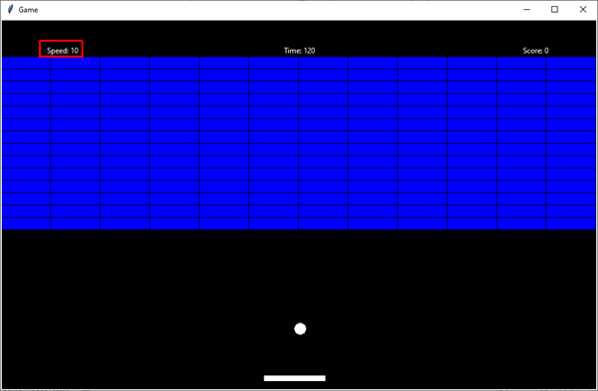**Screenshot 2**
3. 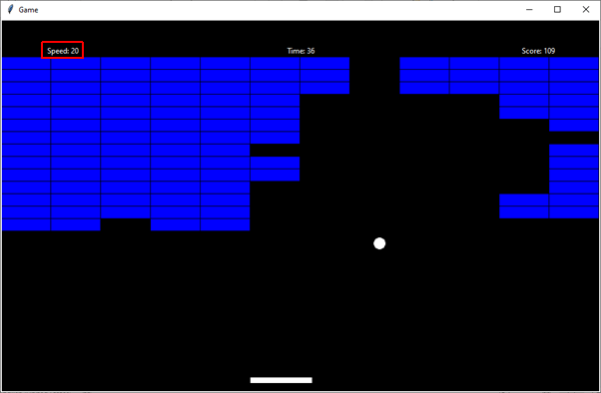**Screenshot 3**
4. 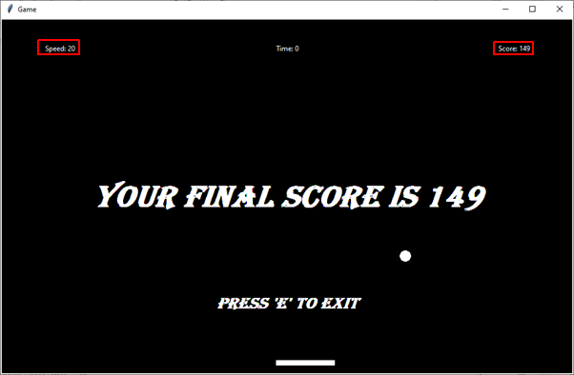**Screenshot 4**

# Limitations

* Keyboard cannot be used to control the paddle
* Speed of the ball cannot be increases/decreased once a round has started

# Requirements

To run this program, Python 3.0 or above must be installed on the system.

Along with Python 3.0 or above, the following modules (other than standard modules) must be installed, if they are not already installed:

* keyboard module

Installation: **pip install keyboard**

* pyautogui module

Installation: **pip install pyautogui**

Operating System: any

A **mouse/pointing device** and **keyboard** are required to play the game.

# Conclusion

Successfully implemented the Brick Breaker game, in Python 3.9.4

As a future scope, a DBMS or file system can be used to keep track of high scores records, as well as more game modes can be implemented into this.

# Bibliography

* Stack Overflow: <https://stackoverflow.com/>
* Geeks-For-Geeks: <https://www.geeksforgeeks.org/>
* Tkinter Module Documentation : <https://docs.python.org/3/library/tk.html>
* Keyboard module Documentation : <https://pypi.org/project/keyboard/>